//

#include <stdio.h>

void pointerArray(int *Fun_startPtr, int *Fun_endPtr); // starting address and ending address of array

void main(void)

{

int intArray[10] = { 0 };

int *startPtr = &intArray[0]; // starting address of array

int *endPtr = &intArray[10]; // ending address of array

size_t k;

for (k = 0; k < 10; k++)

{

intArray[k] = 10 * k;

printf("\n %d", intArray[k]);

}// end for

pointerArray( startPtr, endPtr); // giving the addresses

puts("\n");

}// end main

void pointerArray(int *Fun_startPtr, int *Fun_endPtr)

{

while (Fun_startPtr < Fun_endPtr)

{

printf("\n\nThe value is %d", *Fun_startPtr);

Fun_startPtr++;

} // end while

}// end user

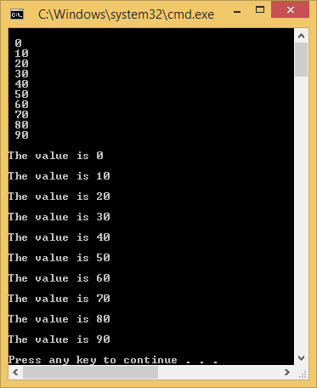

//

#include <stdio.h>

int * pointerArray(int *Fun_startPtr, int *Fun_endPtr, int searchFor); // starting address and ending address of array

void main(void)

{

int intArray[10] = { 0 };

int *startPtr = &intArray[0]; // starting address of array

int *endPtr = &intArray[9]; // ending address of array

int search4 = 30;

size_t k;

for (k = 0; k < 10; k++)

{

intArray[k] = 10 * k;

printf("\n %2d located at %p", intArray[k], &intArray[k]);

}// end for

printf("\n\n%p \n\n", pointerArray(startPtr, endPtr, search4)); // giving the addresses

puts("\n");

}// end main

int * pointerArray(int *Fun_startPtr, int *Fun_endPtr, int searchFor)

{

while (Fun_startPtr <= Fun_endPtr)

{

printf("\n\nThe value is %d", *Fun_startPtr);

if (searchFor == *Fun_startPtr)

{

return Fun_startPtr;

}// end if

Fun_startPtr++;

} // end while

return NULL;

}// end user

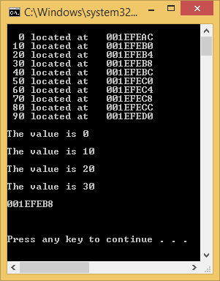

//

#include <stdio.h>

void circleMath(double Fun_radius, double *diameter, double *area);

void main(void)

{

double radius = -1.0;

double diameter = 0.0;

double area = 0.0;

puts("\nEnter a radius:");

scanf_s("%lf", &radius);

circleMath(radius, &diameter, &area);

printf("\nThe diameter is %.8lf \n", diameter);

printf("\nThe area is %.8lf \n", area);

}//end main

void circleMath(double Fun_radius, double *diameter, double *area)

{

double myPi = 3.14159265;

*diameter = 2.0 * Fun_radius;

*area = myPi * Fun_radius * Fun_radius;

}// end user

